**November 2021**

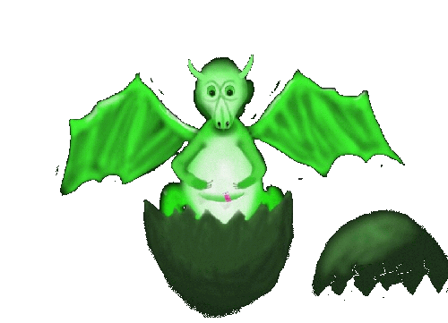 From the Dragons’ Den

The new season of Little Dragons is now underway and it is good to report that everyone is working hard to keep safe and well.

All our newbies have soon learned the ropes concerning what happens in each area; enjoying the art and craft work, especially the week when we did the ‘marble rolling’ pictures. Jackson Pollock has nothing on our little artists.

Storytime is good fun and everyone has got the idea of sitting nicely on the dragon cushions, enjoying the story, joining in singing and marching – that Grand Old Duke is still going up and down the hill, at least twice each session.

I have been dared by one of the Big Dragons to risk the musical instruments, but I have to be well-charged up for that; full of energy. Best to keep it until just before a holiday break as the Musical Director (me) needs much time to recover. I keep suggesting that perhaps one of the other ‘biggies’ leads band practice, but it is amazing to find that they all seem to disappear when it is put before them. Hmmm! A plan will have to be devised!!

Best wishes to all of you from Val and from we three:

George  Uncle Sam and Idris.

