March 2018
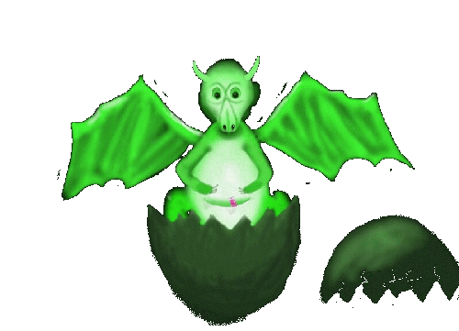 From the Dragons’ Den

Signs of Spring! First of all, snowdrops, then bright golden crocus gleaming on the edge of the lawn, magnolia buds ready to burst forth (hope the wind doesn’t blow too hard this year as it did last year resulting in lots of pinkish-whitish petals strewn across the garden).
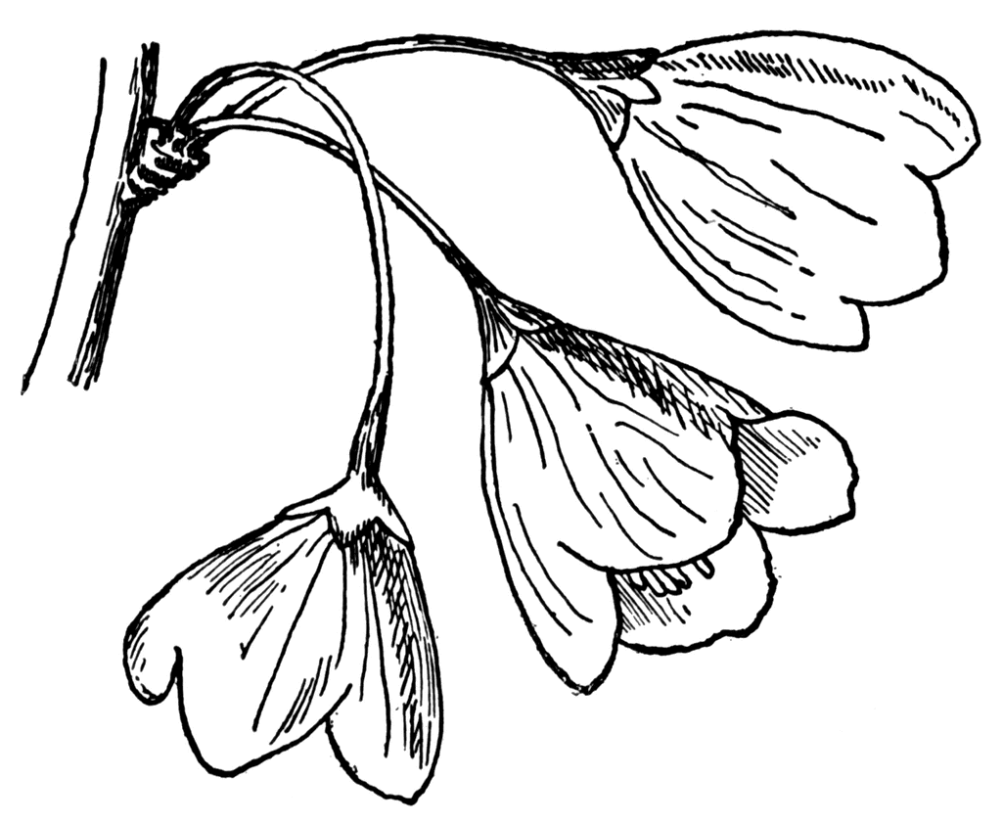
For our Little Dragons, changing seasons don’t often affect them. They enter, follow the usual pathway to their current, chosen item of interest – for some the train set, for some the art and craft table, for some (as ever) the red car before anyone else can take possession. When security is established they may then move on to something new, perhaps requiring more skill.

As day time follows night time many of us follow the same, or similar patterns, throughout our days. They are the things that keep us feeling secure, that life is under our control.

An instance in my own life is my kitchen routine first thing in the morning:-
- Enter kitchen, put water in kettle, switch on, take spoon from drawer;
- cross to microwave and fridge; put 1 ramekin of porridge oats in bowl, open fridge, take out milk and put 2 ramekins of milk into bowl with porridge – place the bowl into the microwave for 2 minutes; milk back in fridge and take out blueberries, selecting required number for porridge;
- during the 2 minutes, make tea which usually synchronises with the ping of the microwave.
Boring, possibly – but it enables me to make my breakfast without having to use any mental energy, thus saving it all for more interesting activities.

So it is with many of our LDs as they follow a former pattern prior to moving on to something more exciting or more stretching. We all need the mundane in our lives while we gather up our creative energy for tackling the unknown or the untried.

My own unknown, untried, certainly not mundane, future activity will be a flight in a glider! My lovely family decided that this would make a really exciting present on the occasion of a recent birthday. Very exciting! Will I, like our Little Dragons, pluck up the courage to try the new experience, to leap into the unknown? Watch this space.
 Every good wish, Val

